**Selenium Locators Assignment:**

**Problem 1**- Open 4 web

|  |
| --- |
| [https://phptravels.net/api/uploads/globallogo.png](https://phptravels.net/api/uploads/global/logo.png) |

site and locate the following and Write xpath.

* PHPTRAVLES Logo
* Home
* Flights
* Tours
* Company
* Signup Btn
* Login Btn
* Agents DropDown

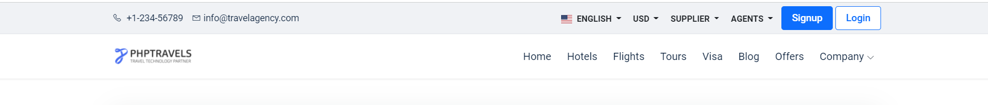

*Note - You have to use Id, Name, Class, CSS Selector, TagName and write Relative and absolute xpath*

**Problem 2**- Write **Xpath** for Below Web elements using Xpath Axes (such as preceding, following, ancestor, following-sibling etc..)

* Check in - Calendar Icon
* Check Out – Calendar Icon
* “- ” for Adults
* “+” for Adults
* “-“ for Childs
* “+” for Childs

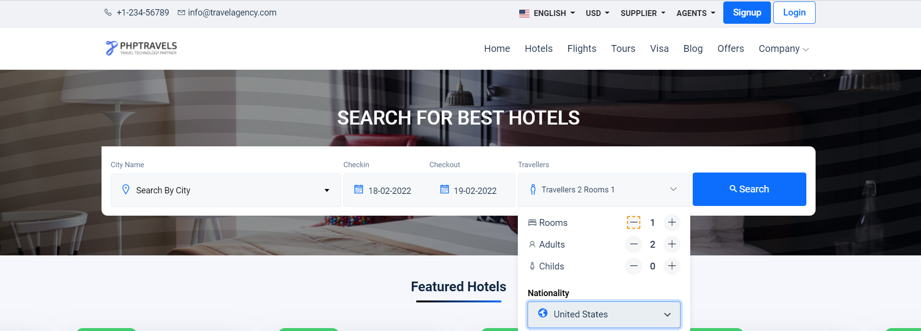

**Note : Don’t Use Indexes**

**1.**

**Relative Paths:-**

//img[@src='[https://phptravels.net/api/uploads/global/logo.png'][@alt='logo']](https://phptravels.net/api/uploads/global/logo.png%27%5d%5b@alt=%27logo%27%5d)

//a[@href='[https://www.phptravels.net/'][@title='home']](https://www.phptravels.net/%27%5d%5b@title=%27home%27%5d)

//a[@href='[https://www.phptravels.net/flights'][@title='home']](https://www.phptravels.net/flights%27%5d%5b@title=%27home%27%5d)

//a[@href='[https://www.phptravels.net/tours'][@title='home']](https://www.phptravels.net/tours%27%5d%5b@title=%27home%27%5d)

//a[@href='company']

//a[@href='[https://www.phptravels.net/signup']](https://www.phptravels.net/signup%27%5d)

//a[@href='[https://www.phptravels.net/login'][@class='dropdown-item](https://www.phptravels.net/login%27%5d%5b@class=%27dropdown-item) waves-effect']

//button[@id='agents']

**Absolute Paths:-**

/html/body/header/div[2]/div/div/div/div/div[1]/a/img

 //*[@id="fadein"]/header/div[2]/div/div/div/div/div[2]/nav/ul/li[1]/a

/html/body/header/div[2]/div/div/div/div/div[2]/nav/ul/li[3]/a

/html/body/header/div[2]/div/div/div/div/div[2]/nav/ul/li[4]/a

/html/body/header/div[2]/div/div/div/div/div[2]/nav/ul/li[8]/a

 /html/body/header/div[1]/div/div/div[2]/div/div/a[1]

 /html/body/header/div[1]/div/div/div[2]/div/div/a[2]

 /html/body/header/div[1]/div/div/div[2]/div/div/div[4]/div/button

**2.**

Check in:

RELATIVE PATH://*[@class ="hotels-search"]/div/div/div[2]/div/div[1]/div/span/self::span

ABOLUTE PATH: /html/body/section[1]/section/div/div/form/div/div/div[2]/div/div[1]/div/span/self::span

Check out:

RELATIVE PATH://*[@id="hotels-search"]/div/div/div[2]/div/div[2]/div/span/parent::div

ABOLUTE PATH: /html/body/section[1]/div/div/div/div/div[2]/div/div[1]/form/div/div/div[2]/div/div[2]/div/span/parent::div

“-“ for Adults

RELATIVE PATH: //*[@id="hotels-search"]/div/div/div[3]/div/div/div/div/div[2]/div/div/div[1]/i/following::input

ABOLUTE PATH: /html/body/section[1]/div/div/div/div/div[2]/div/div[1]/form/div/div/div[3]/div/div/div/div/div[2]/div/div/div[1]/i/following::input

“+” for Adults

RELATIVE PATH: //*[@id="hotels-search"]/div/div/div[3]/div/div/div/div/div[2]/div/div/div[2]/i/parent::div

ABSOLUTE PATH: /html/body/section[1]/div/div/div/div/div[2]/div/div[1]/form/div/div/div[3]/div/div/div/div/div[2]/div/div/div[2]/i/parent::div

“+” for Childs

RELATIVE PATH: //*[@id="hotels-search"]/div/div/div[3]/div/div/div/div/div[3]/div/div/div[2]/i/ancestor::div

ABSOLUTE PATH: /html/body/section[1]/div/div/div/div/div[2]/div/div[1]/form/div/div/div[3]/div/div/div/div/div[3]/div/div/div[2]/i/ancestor/div

* RELATIVE PATH : //*[@id="hotels-search"]/div/div/div[3]/div/div/div/div/div[3]/div/div/div[1]/i/following::input#qtyInput_hotels

ABSOLUTE PATH : /html/body/section[1]/section/div/div/form/div/div/div[3]/div/div/div/div/div[3]/div/div/div[1]/i